MS SQL SERVER
Standard Operating Procedures
(SOP)
Security consideration for a SQL Server Installation
Submitted to



BY



CIS, Wipro Limited

Document Details

Project Name | Innogy SE
Account | CIS
IT Component/Application Title | Security consideration for a SQL Server Installation
Current Version | 1.5
List of Contributors | Pradipkumar Kansara, Kiran Bhalekar, Ayushi Gautam, Sivakumar Goud, Ayushi Srivastava
Customer Contact Information

Version History
(All revisions made to this document must be listed in chronological order. All revisions must be approved. Review and Approval can be done by an internal source or by the customer)
Version | Date of Revision | Description | Author | Reviewed By | Approved By
1.0 | 29-08-2015 | Initial Draft | Kiran Bhalekar | Pradipkumar Kansara | Mahesh Keshatwar
1.1 | 04-09-2015 | Document Completed | Kiran Bhalekar | Pradipkumar Kansara | Mahesh Keshatwar
1.2 | 21-08-2016 | Updated document to standard format | Kiran Bhalekar | Pradipkumar Kansara | Mahesh Keshatwar
1.3 | 17-05-2017 | Wipro and Innogy Logo changed | Ayushi Gautam | Pradipkumar Kansara | Mahesh Keshatwar
1.4 | 14-09-2017 | Updated document to Wipro Standard format with header and footer | Sivakumar Goud | Pradipkumar Kansara | Santosh Badiger
1.5 | 11-12-2018 | Updated the content | Ayushi Srivastava | Pradipkumar Kansara | Santosh Badiger

Document Distribution List
Sl. No. | Name and Company | Purpose
1 | RWEIT-SQLDBA | Document is useful at the time of SQL server installation in security aspect.
2

TABLE OF CONTENT

1. Purpose 1
2. Scope 1
3. Before Installing Sql Server 1
3.1 Enhance Physical Security 1
3.2 Use Firewalls 1
3.3 Isolate Services 2
3.4 Configure a Secure File System 2
3.5 Disable NetBIOS and Server Message Block 3
4. After Installing Sql Server 3
5. Reference 4

Purpose
This document is prepared for Security Considerations for a Sql Server Installation in SQL Server Database Administration Services at <Customer Name>.

Scope
This document is prepared for GSMC Wipro sustenance team and provides the concepts of Security Considerations for a Sql Server Installation for the administration of the SQL Server database at <Customer Name>.

Before Installing Sql Server

Enhance Physical Security
Physical and logical isolation make up the foundation of SQL Server security. To enhance the physical security of the SQL Server installation, do the following tasks:
- Place the server in a room accessible only to authorized persons.
- Place computers that host a database in a physically protected location, ideally a locked computer room with monitored flood detection and fire detection or suppression systems.
- Install databases in the secure zone of the corporate intranet and do not connect your SQL Servers directly to the Internet.
- Back up all data regularly and secure the backups in an off-site location.

Use Firewalls
Firewalls are important to help secure the SQL Server installation. Firewalls will be most effective if you follow these guidelines:
- Put a firewall between the server and the Internet. Enable your firewall. If your firewall is turned off, turn it on. If your firewall is turned on, do not turn it off.
- Divide the network into security zones separated by firewalls. Block all traffic, and then selectively admit only what is required.
- In a multi-tier environment, use multiple firewalls to create screened subnets.
- When you are installing the server inside a Windows domain, configure interior firewalls to allow Windows Authentication.
- If your application uses distributed transactions, you might have to configure the firewall to allow Microsoft Distributed Transaction Coordinator (MS DTC) traffic to flow between separate MS DTC instances. You will also have to configure the firewall to allow traffic to flow between the MS DTC and resource managers such as SQL Server.

Isolate Services
Isolating services reduces the risk that one compromised service could be used to compromise others. To isolate services, consider the following guidelines:
- Run separate SQL Server services under separate Windows accounts. Whenever possible, use separate, low-rights Windows or Local user accounts for each SQL Server service.

Configure a Secure File System
Using the correct file system increases security. For SQL Server installations, you should do the following tasks:
- Use the NTFS file system (NTFS). NTFS is the preferred file system for installations of SQL Server because it is more stable and recoverable than FAT file systems. NTFS also enables security options like file and directory access control lists (ACLs) and Encrypting File System (EFS) file encryption. During installation, SQL Server will set appropriate ACLs on registry keys and files if it detects NTFS. These permissions should not be changed. Future releases of SQL Server might not support installation on computers with FAT file systems.

Disable NetBIOS and Server Message Block
Servers in the perimeter network should have all unnecessary protocols disabled, including NetBIOS and server message block (SMB).
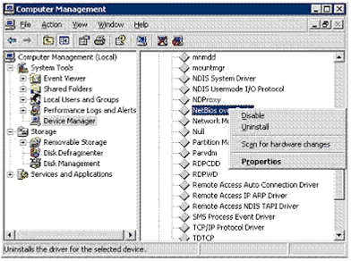
NetBIOS uses the following ports:
- UDP/137 (NetBIOS name service)
- UDP/138 (NetBIOS datagram service)
- TCP/139 (NetBIOS session service)
SMB uses the following ports:
- TCP/139
- TCP/445
Web servers and Domain Name System (DNS) servers do not require NetBIOS or SMB. On these servers, disable both protocols to reduce the threat of user enumeration.

After Installing Sql Server
After installation, you can enhance the security of the SQL Server installation by following these best practices regarding accounts and authentication modes:
Service accounts
- Run SQL Server services by using the lowest possible permissions.
- Associate SQL Server services with low privileged Windows local user accounts, or domain user accounts.
- 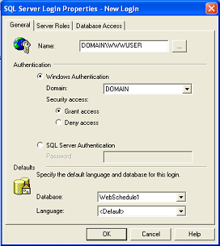
Authentication mode
- Require Windows Authentication for connections to SQL Server.
- Use Kerberos authentication.
Strong passwords
- Always assign a strong password to the sa account.
- Always enable password policy checking for password strength and expiration.
- Always use strong passwords for all SQL Server logins.

Reference
- http://msdn.microsoft.com/en-us/library/ms144228.aspx#physical_security

